Gun Violence

Team members:

Jialin Yu (Team Rep) | Class of 2023 | [Jialinyu@bu.edu](mailto:Jialinyu@bu.edu)

Youheng Yang | Class of 2023, [gregori0@bu.edu](mailto:gregori0@bu.edu)

Yujie Yan | Class of 2023, | [cdyyj@bu.edu](mailto:cdyyj@bu.edu)

Jiahang Li | Class of 2023 | [jiahang@bu.edu](mailto:jiahang@bu.edu)

## 

## 

## 

## Introduction:

### Project Overview

Gun violence is a significant issue affecting many communities in the United States, including District 4 in Boston. It is a complex problem that demands a multi-faceted approach to understanding the underlying causes and developing effective solutions. Councilor Worrell, a Boston City Councilman for District 4, is dedicated to addressing this challenge and improving the safety and well-being of his constituents. This project aims to analyze gun violence in District 4 and the broader city, identify key variables associated with its occurrence, and evaluate existing programs designed to mitigate the issue. The ultimate goal is to provide valuable insights that can inform data-driven policies and strategies for reducing gun violence in the district and throughout Boston. By understanding the drivers of violence, policymakers and community leaders can work together to create a safer environment for all residents.

The project is conducted in several phases, beginning with a comprehensive analysis of gun violence in District 4 and the city of Boston. This includes an examination of the volume, geographic distribution, and trends of gun-related incidents. We assess factors such as police presence, poverty levels, population movements, and other socio-economic variables to determine their correlation with gun violence rates.

We then conducted a comparative analysis to identify differences and similarities between District 4 and other districts in terms of gun violence rates and the underlying factors contributing to those rates. This comparison helps determine the unique challenges faced by District 4 and provides a better understanding of the context in which potential solutions can be implemented.

Finally, we creatively explore additional data about the school part to uncover compelling insights related to gun violence.

### Impact

The potential impact of this project is substantial, as it seeks to improve the safety and well-being of residents in District 4 and throughout the city of Boston. By identifying the root causes of gun violence and evaluating the effectiveness of existing programs, the project can inform the development of targeted policies and strategies that address the issue more effectively. In the long term, this could lead to a significant reduction in gun violence, fostering safer communities and enhancing the overall quality of life for Boston residents.

### Base Analysis

**What are the drivers of violence in District 4? How does this compare to the rest of the city?**

Figure 1.1 is a histogram of the number of residents with different races revealing that D4 and D5 have a high proportion of African American residents compared to other districts and compared to other races in the same district. What’s more, the district with relatively fewer shootings has a higher proportion of Asian and White residents. This indicates a lack of resident diversity, which could be a contributing factor to gun violence in District 4.

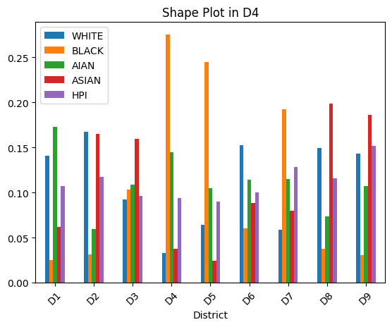[Figure 1.1]

Figure 1.2 is a histogram of buyers' number of firearms in different districts. Our analysis of firearm transactions indicates that District 4 experiences a higher volume of deals compared to other districts. The prevalence of firearm transactions in the area could be a significant factor contributing to the increased gun violence observed in District 4.

The buyer plot shows that District 4 has the highest number of gun buyers among all districts, suggesting a strong demand for firearms in the area. This heightened demand for guns could be one of the underlying causes of violence in District 4, as it may result in more firearms circulating within the community and, consequently, an increased likelihood of gun-related incidents.

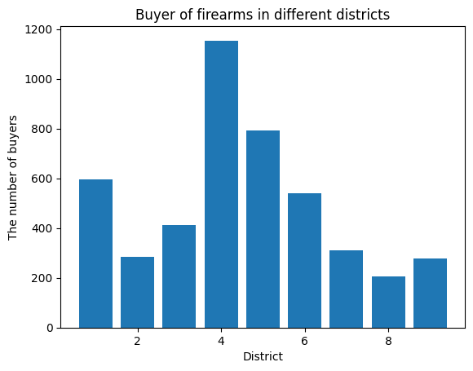

[Figure 1.2]

**What is the rate of gun violence in District 4? How does this compare to the rest of the city?**

According to figure 1.3, around 35% of the gun violence are taken place in District 4, and around 23% are taken place in D7, which is the district right near District 4. To sum up, 58% of gun violence took place in these two districts for the past 5 years, which is significantly higher than in other districts.

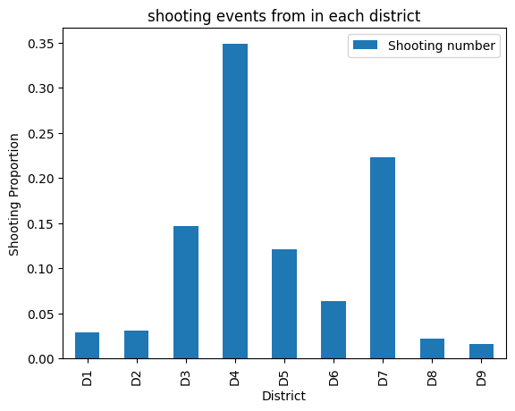

[Figure 1.3]

**Are there patterns of violence in terms of location in District 4? How does this compare to the rest of the city?**

Gun violence is dispersed throughout District 4, affecting numerous neighborhoods within its boundaries. In comparison to the rest of the city, District 4 exhibits a higher density of incidents, highlighting the urgency of addressing this issue in the area. This stark contrast emphasizes the need for a comprehensive analysis of the factors contributing to gun violence in District 4 and the implementation of targeted solutions to create a safer community for its residents.

In District 4, Washington Street has the most number of shooting occur. And we list the top 10 shooting streets and the location for the top 5.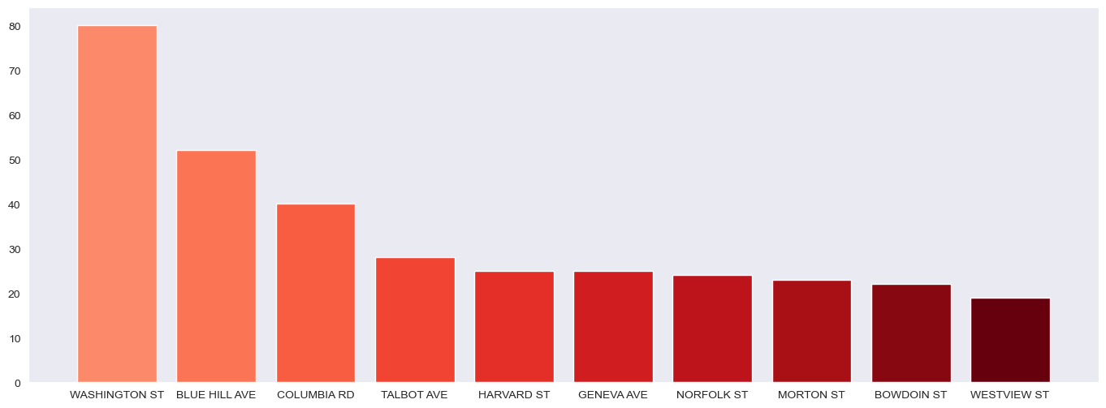[Figure 2]

(This histogram is the top 10 streets where most shooting events happened in District 4.)

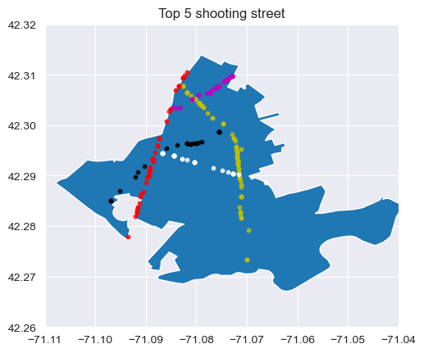

[Figure 3]

(This graph is the shape of District 4, and the scatter point on the graph is the location of the shooting events in the top 5 shooting street

The yellow scatter points are shooting on Washington street

The red scatter points are shooting on blue hill ave

The magenta scatter points are shooting on Columbia Rd.

The white scatter points are shooting on talbot ave.

The black scatter points are shooting on Harvard st)

In addition, we plot crime incidence locations within D4 for better illustration.

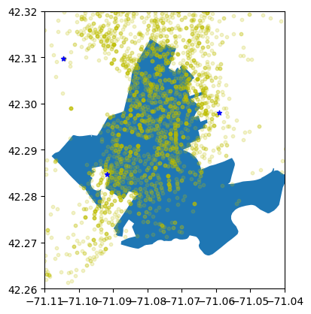

The yellow point represents the location of gun violence incidences and the blue stars represent the location of police stations. We can see that most of the crimes concentrate in the northern and western parts of D4. Most of the crime took place near the park. We are not able to find the reasons contributing to this correlation, but we suspect this phenomenon might be related to there being a highway surrounding the park. And there are more crimes concentrated around the B3 police station compares to other police stations. To emphasize, the figure does show an important fact that worth notice is that D4 does not have a police station precisely.

**Are there patterns in terms of the type of violence in District 4? How does this compare to the rest of the city?**

The top 6 proportions for the type of violence in D4 are Aggravated Assault, Homicide, Warrant Arrests, Robbery, Ballistics, and Firearm Violations. And the top 6 proportions for the type of violence in the Rest cities are Aggravated Assault, Homicide, Warrant Arrests, Ballistics, Firearm Violations, and Search Warrants. As we can see the proportion of robbery in D4 is higher than the proportion in the rest of the cities. There is no police station inside the D4 might be a potential cause.

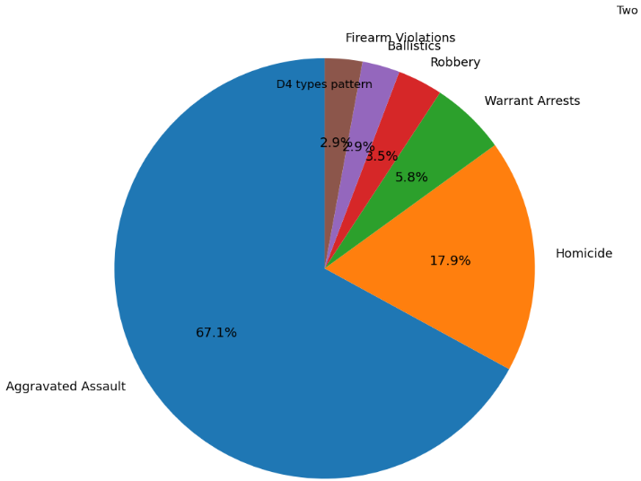

[Figure 4.1]

(This pie chart is showing the proportion of shooting crime in district 4)

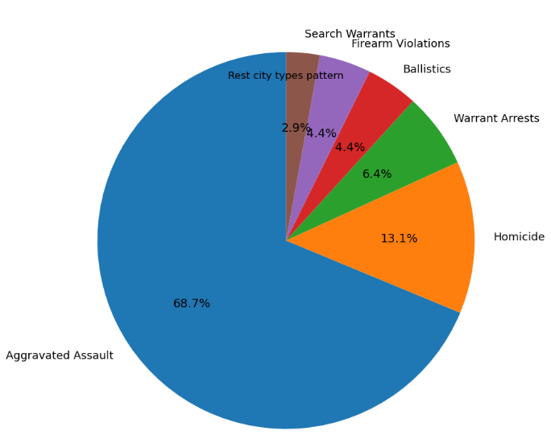

[Figure 4.2]

(This pie chart is the type of shooting crime in the rest of the cities)

### Extension Analysis

**School part:**

In the school part, we use the datasets from the Department of Elementary and Secondary Education(DESE) in Massachusetts. Generally, I have about 300 to 400 data in each dataset, and we filter out the schools in Boston. We first locate all schools in Boston by checking the zip code. We found that there’re around 30 schools in Boston. Then, we search each school one by one and identify the district area they belong to. Finally, we successfully find four schools in District 4: Brooke Charter School, Codman Academy Charter Public, KIPP Academy Boston Charter School, and UP Academy Charter School of Dorchester. For other districts, we find 1 to 5 schools expect District 6

After cleaning the dataset, we start to find the features that possibly relate to gun violence. Based on the data we have, we mainly analyze the following aspects: school discipline, attendance, enrollment, and performance.

In the following plots, the index 0 represents the expected value in Boston, and the index 1 - 9 represents District 1 to 9.

School Discipline:

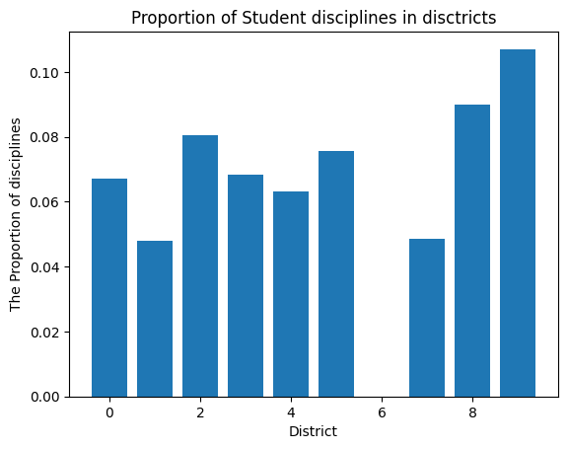

School Attendance:

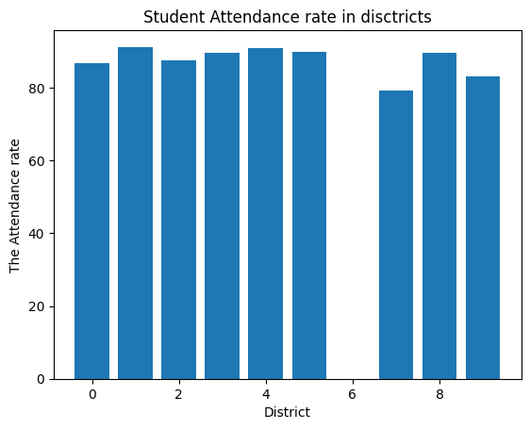

Attendance rate of schools in District 4 compared to Boston

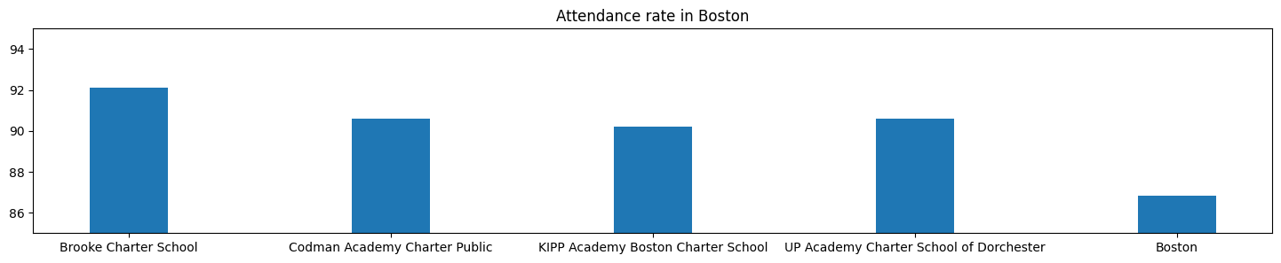

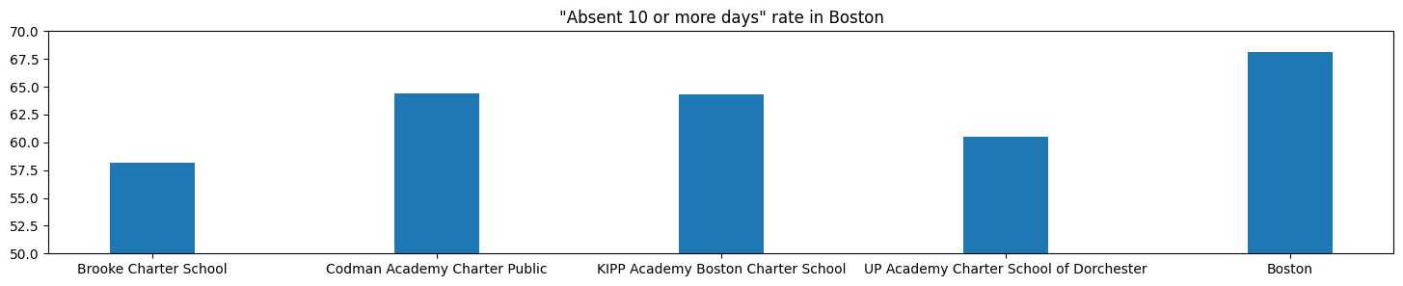

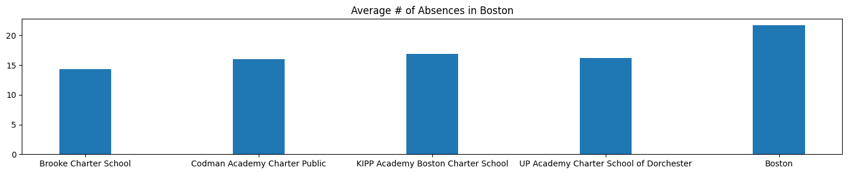

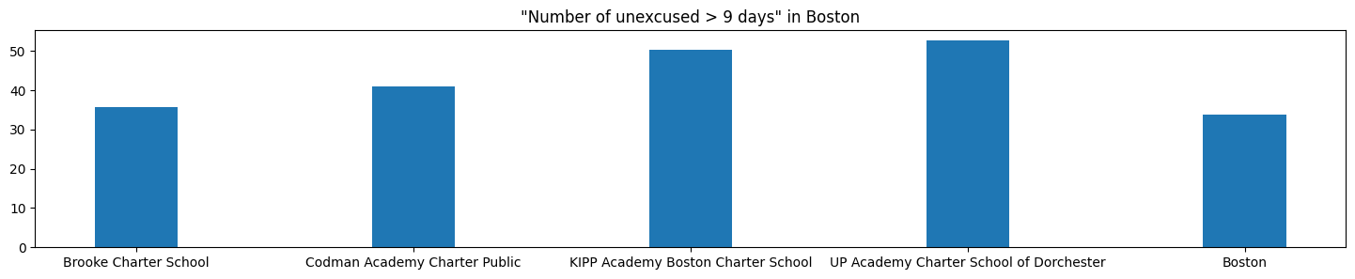

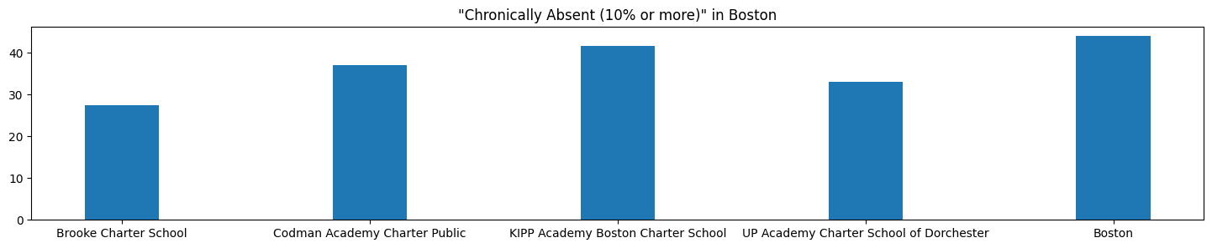

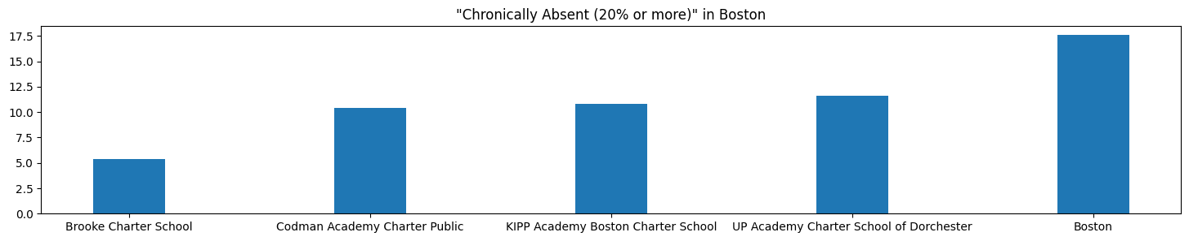

School Enrollment:

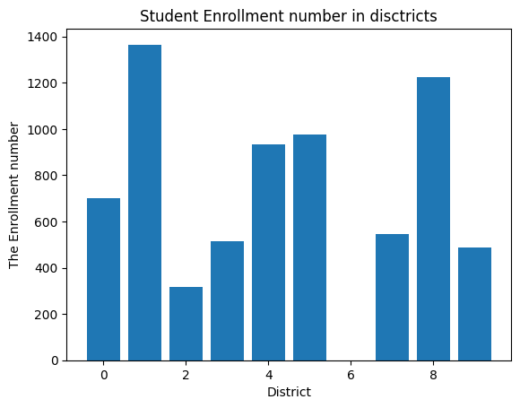

School Performance:

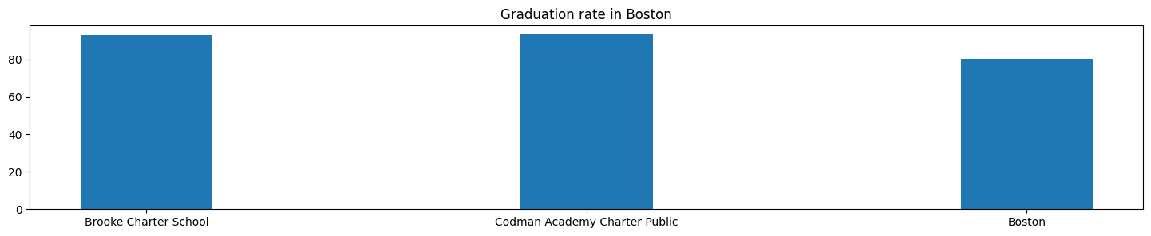

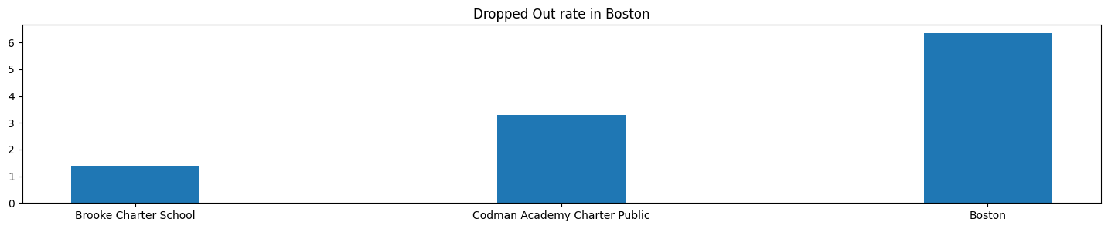

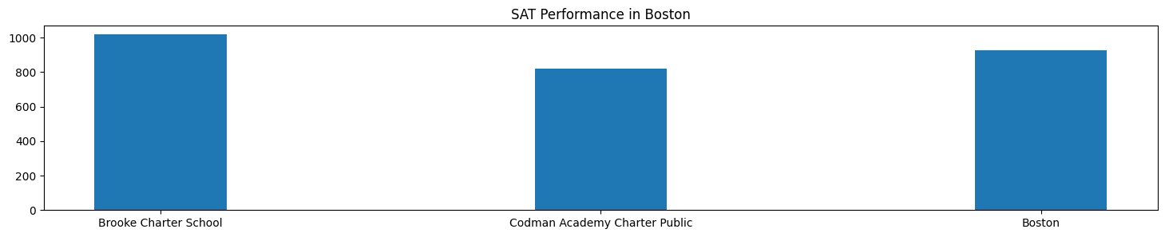

Although various factors may contribute to the prevalence of gun violence in schools, it appears that higher attendance rates and fewer absences do not have an obvious positive impact on reducing gun violence. Similarly, a decrease in the number of chronically absent students does not necessarily lead to a notable reduction in such incidents. Reducing absenteeism, in general, does not seem to have a clear, positive correlation with decreased gun violence either. However, it is important to note that lower enrollment rates may potentially lead to a negative effect on gun violence, as smaller student populations might create an environment that fosters increased tensions or feelings of isolation, which could contribute to violent incidents. Further research is needed to better understand the complex relationship between school attendance, enrollment, and gun violence.

**Does transportation have an impact on Gun Violence?**

We also analyze the MBTA stops in each district compared to the shooting events.

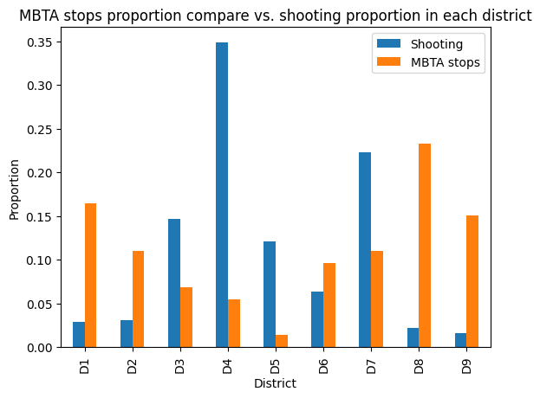

[Figure ]

According to the above figure, the district with the small number of shooting incidence tend to have more MBTA stops while D4, which is the district with the huge number of shooting events has relatively fewer MBTA stops. As a result, there is a correlation between shooting incidence and MBTA stops, but the number of MBTA stops might not be the factor of gun violence. To dig deeper, we produce a map that compares the location of gun violence and the location of MBTA stops, this is shown in the below figure.

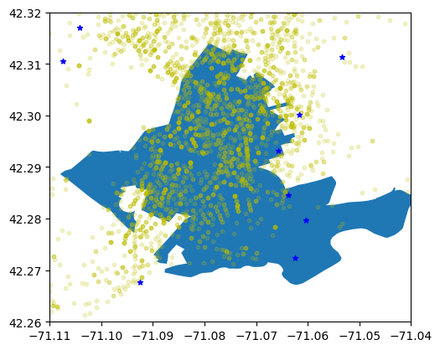

In the above figure, the yellow points represent the location where gun violence takes place and the blue stars represent the MBTA stop. The figure above proves our proposal that MBTA stops correlate with gun violence. It illustrates that there is less yellow point around the blue points compared to other areas.

### 

### Challenges

There are many challenges associated with this project. One of them is the absence of geographical information for certain data sets, making it difficult to represent them on a map. Additionally, some data sets have different geographical naming conventions, making it challenging to establish correlations. Worse, some of them do not have longitude and latitude information, which leads to another problem: not being able to classify the shooting event to each district. Especially for highly similar districts D4 and D7 (overlap zip code). Thus, this might lead to data inaccuracy. One objective we would like to have is to identify the relationship between the volume of pedestrian traffic and the incidence of shootings in a city, but unfortunately, we could not locate any data containing this information.

### 

### Team Member Contribution

Jialin Yu: Analyze Shape Dataset, and building shape plots that later are used. Comparing the population distribution in different districts, shootings, and crime locations in D4. Analyze the relationship between the location of police stations and the location of crime, including shootings events. Benchmarking the relationship between the number of MBTA stops with the frequency of shootings.

Yujie Yan: Collected the crime incidents from 2015 to 2021. Processed the data by filtering out shooting events and extracting the location for each incident. Identify the top 5 streets with the highest shooting rate in district4. Plot the identified street on the District 4 map. Identify the pattern of crime in District 4 and the rest of the cities.

Jiahang Li: Violent & Crime Part, established what violence looks like in D4 and the whole city, extension data for the school.

Young Yang: finished the Firearm transaction and analyzed the school district part.